## PROTEINSYNTHESIS

The genetic information for the synthesis of proteins and other enzymes resides in DNA and the actual synthesis takes place in cytoplasm. Two French scientists of pasture institute, F. Jacob and J. Monod proposed about the existence of a messenger for communication between DNA and the protein synthesizing machinery in the cytoplasm and later this was called the mRNA (messenger RNA).

A particular segment of DNA, that is a gene, which becomes active, in a manner similar to the replication of DNA during cell division, serves as a template for the formation of RNA, which contains a sequence bases of that is complementary to one strand of DNA (antisense strand, which serves as its template) and identical to the other strand of DNA (sense strand). This process of production of mRNA from DNA is called transcription. The RNA polymerase which catalyses the synthesis of RNA from the DNA template is known as transcriptase. Actually in eukaryotic cells, it was found that the RNA molecule immediately after transcription is many times longer than the RNA that enters cytoplasm. Hence, this RNA was named as heterogeneous RNA (hnRNA). This hnRNA is processed in the nucleus itself by deleting intervening sequences called introns and the expressed sequences that are retained are known as exons. This hnRNA is further processed by capping with methyl guanosine at the 5’ end and by addition of a number of adenines (poly -A) at 3’ end. This capping and addition of poly A tail is supposed to protect the mRNA from degradation by cytoplasmic enzymes.

The process of protein synthesis where amino acids are brought by the tRNA and sequentially arranged based on the codons of the mRNA is known as trans lation (i. e. the nucleotide sequence is translated into the amino acid sequence). The translation process requires mRNA, rRNA, ribosomes, 20 kinds of aminoacids and their specific tRNAs and many translation factors. The process of translation (protein synthesis) consists of five major steps viz., (1) activation of aminoacids (2) transfer of aminoacids to tRNA (3) chain initiation (4) chain elongation and (5) chain termination. Each step is governed by specific enzymes and cofactors.

In the cytoplasm, the amino acids are activated in the presence of ATP and linked to their respective tRNAs by a process called charging of tRNA in the presence of an enzyme aminoacyl synthetase. Thus a number of tRNA molecules, pick up aminoacids freely floating in the cytoplasm and forms aminoacyl-tRNAs.

The processed mRNA enters the cytoplasm and binds to ribosomes, which serve as work benches for protein synthesis. The ribosome consists of rRNAs and different proteins. Ribosome contains two subunits; the large subunit and the small subunit. The process of translation starts when an initiating aminoacylatedtRNA base pairs with an initation codon of an mRNA molecule that has been located by the small subunit of ribosome. Then the larger subunit joins. Two separate and distinct sites are available in the ribosome to which the tRNAs can bind; A (acceptor or aminoacyl attachment) site and P (peptidyl) site. An aminoacyl-tRNA first attaches to site A (acceptor site or aminoacyl attachment site) the kind of aminoacyl t-RNA being determined by the sequence of mRNA (codon) attached to site A. The peptide bonds are formed between the aminoacids which is catalysed by the enzyme peptidyl transferase. The peptidyl tRNA along with the mRNA codon moves to the P (peptidyl) site making the A site available for the attachment of a new aminoacyl-tRNA. Thus the translation proceeds and at the end a releasing factor binds to the stop codon terminating the translation. The ribosome releases the polypeptide and mRNA and subsequently dissociates into two subunits. Further processing of polypeptide chain into proteins and enzymes is done in the cytoplasm itself and depends upon the bonding properties of the amino acids joined in them.

Most of the mRNA molecules are unstable and degraded after the release of polypeptide chain, but some mRNAs such as those coding for hemoglobin may be stable. When the cell needs large quantities of a particular enzyme or protein, more number of mRNA molecules coding for the same protein are produced to meet the demand.

**Polyribosomesorpolysomes:**ManyribosomesreadonestrandofmRNAsimultaneously, helping to synthesize the same proteinat different spots on themRNA.

**Cistron:**Asubdivisionofgenewhichactsasaunitoffunctionwithagene.

**Muton:**Asubdivisionofgenewhichisthesiteofmutation.

**Recon:**Thesmallestsubunitofgenecapableofundergoingrecombinationorasub unitofgenewhichisthe siteofrecombination.

**GENEREGULATION**

Genesthatencodeaproductrequiredinthemaintenanceofbasiccellularprocessesorcellarchitecturearecalledhousekeepinggenesorconstitutivegenes.Aconstructivegeneisanunregulatedgene,whoseexpressionisuninterrupted,incontrasttotheregulatedexpressionofagene.Thestudiesofbacterialgeneticsindicatethatallgenesnotonlyspecifythestructureofanenzymebutsomeofthemalsoregulatetheexpressionofothergenes.Thesegenesarecalledregulatorgenes.ThisconceptofgeneregulationhasbeenstudiedbyF.JacobandJ.Monodin1961in*E.coli,*whoproposedtheoperonconcept.

Accordingtotheoperonconcept,generegulationinprokaryotesandbacteriophagesinvolvesstructuralgenes,theoperator,thepromoter,theregulatorgenes, repressor proteins andan inducer.

**LacOperonof*E.coli***

A genetic unit that consists of one or more “structural genes” (cistrons thatcode for polypeptides) and an adjacent “operator– promoter” region that controlsthetranscriptionalactivityiscalledoperon.Operatorandpromoterareupsteamto the structural genes.Thus an operon refers to a group of closely linked geneswhichacttogetherandcodeforvariousenzymesrequiredforaparticularbiochemical pathway.Lac operonconsistsofseveralcomponentswhicharebriefly describedbelow:

## Structuralgenes

The lactose operon of *E. coli*is composed of three structural genes *z*, *y* and*a* the ‘*z*’ gene codes for an enzyme ß-galactosidase, which converts lactose intoglucoseandgalactose.The‘*y’* genecodesforanenzymepermease,whichfacilitates the entry of lactose into the cell.The ‘*a*’ gene specifies the enzymethiogalactoside trans acetylase, which transfers an acetyl group from acetyl co-A toß-galactoside. Hence all the three gene products in lac operon are required for themetabolismoflactose. Such genes, which are sequential and transcribed as asinglem-RNA from a single promoter are called structural genes. The m-RNAsynthesized is the polycistronic mRNA. Only the last cistron has the signals for theterminationoftranscription.

## TheLacoperon-showingitsgenesanditsbindingsites

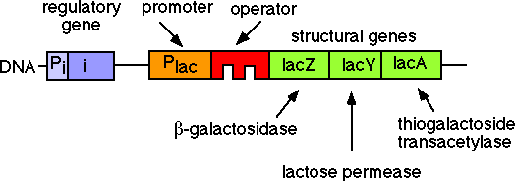

**Theoperatorregion**

Operator lies immediately upstream to the structural genesbetween thepromoter and structural genes. Operator is the targetsite for the attachment ofrepressorproteinproducedbytheregulatorgene.Bindingofrepressorwithoperator prevents initiation of transcription by RNA polymerase. When operator isfree,theRNApolymerasecanbindtothepromotertoinitiatethemRNAsynthesis.

## Thepromoterregion

The actual site of transcription initiation is known as promoter region. It alsoliesupstreamtothestructuralgenesnexttotheoperatorregion.mRNAtranscription by the structural gene is catalysed by an enzyme RNA polymerase.This enzyme first binds to the promoter region and then moves along the operatorregionand structuralgenes.

## Regulatorgene

Regulatorgene(*i*)specifiesarepressorprotein,whichintheabsenceoftheinducer(lactose),boundtotheoperator(o),therebyinactivatingtheoperatorandpreventingtranscriptionofthethreestructuralgenesbyRNApolymerase.Inthepresenceofaninducer(lactose),therepressorisinactivated by interactionwith the inducer. This allows the RNA polymerase to bind to the promoter allowingthetranscriptionoftheadjacentstructuralgenes.

## Repressor

Repressor is a protein molecule specified by the regulator gene. Repressormay be in active form or inactive form. In the active form, repressor binds to theoperatorregionandpreventstranscription.Whentherepressorisininactivateform,thetranscriptiontakesplace.

## Inducer

The inducer binds to the repressormaking it inactive such that itcannotblindtotheoperator.RNApolymerasepathwayisclearedallowingtheexpressionofstructuralgenes.Afewmoleculesoflactosepresentinthecytoplasmof*E. coli*aremetabolizedintoallolacatose,whichisanisomeroflactose.Suchmoleculesthatinducetheexpressionofanyoperonbybindingtothe repressorarecalledinducersandsuchoperonsareinducibleoperons.

## RegulationofLacOperon

In an uninduced*E. coli,* repressor protein blinds to the operator.Hence,expressionofstructuralgenesisnotinduced.*E.coli*initiallycontainsafewmoleculesofß-galactosidase enzyme. A few molecules of lactose slowly diffuseintocytoplasm.ß-galactosidasepresentincytoplasmmetaboliseslactoseintoallolactose which acts as aninducer. In an induced*E. coli,* allolactose blinds torepressorprotein.Therepressorproteinisdetachedfromtheoperator.RNApolymeraseallowsthetranscriptionofstructuralgenestosynthesizeapolycistronicmRNA.PermeasesynthesizedfrommRNAallowstherapiduptakeoflactose.Largenumberofß-galactosidasemoleculesinthecytoplasmmetaboliselactoseintogalactoseandglucose.

## Inthe"repressedoruninduced"state,therepressorboundtotheoperator

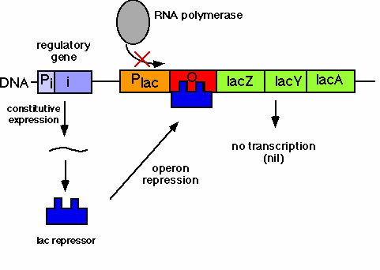

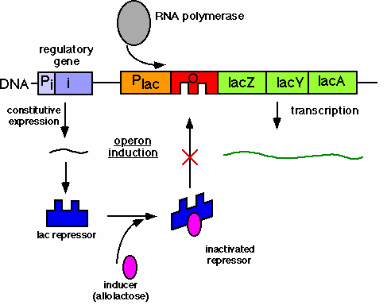

**Inthe"induced"state,thelacrepressorcannotboundtotheoperatorsite**